
PAF-Karachi Institute of Economics & Technology
(The Center of Excellence)
College of Computing and Information Sciences
Software Engineering Course Project Proposal Form

Sno. | Stud. ID | Names | Course Name/CID
1 | 10611 | Alina Fahim | Software Engineering  (109120)
2 | 10420 | Hafsa Kanwal | Software Engineering  (109120)
3 | 10609 | Aqsa Hussain | Software Engineering  (109120)
4 | 10481 | Fizza Ishaq | Software Engineering  (109120)

Project Title: Inventory Management System
- Motivation:
With changing market conditions, our goal was to create a more efficient
replenishment method that would maximize profits for everyone.
- Functional Features
Specify the features of your project which would make it significant for the evaluators.
- If you are designing a project, which is in common use then you should specify those features which are making your project distinctive/unique in comparison with the existing ones “Totally a professional concept of implementing a CRUD based Product”.
- Indicate the utilization/benefits of your project “Will demonstrate implemention of all engineering activities expected under different pahses of SDLC on Product Development”.
- List down 5 unique but relevant Modules/Features for 5 members
  - Module 1: Login Authentication (Common for all members)
  - Module 2:Customers
  - Module 3: Vendors
  - Module 4: Products
  - Module 5: Categories of items

- Expected Detail of all Modules to be covered by each Member
Alina Fahim: Login + Customers
- Demonstration of Create actitivty on Customers
- Demonstration of Review actitivty on Customers
- Demonstration of Update actitivty on Customers
- Demonstration of Delete actitivty on Customers
- Demonstration of Search actitivty on Customers

Hafsa Kanwal: Login + Vendors
- Demonstration of Create actitivty on Vendors
- Demonstration of Review actitivty on Vendors
- Demonstration of Update actitivty on Vendors
- Demonstration of Delete actitivty on Vendors
- Demonstration of Search actitivty on Vendors

Aqsa Hussain: Login + Products
- Demonstration of Create actitivty on Products
- Demonstration of Review actitivty on Products
- Demonstration of Update actitivty on Products
- Demonstration of Delete actitivty on Products
- Demonstration of Search actitivty on Products

Fizza Ishaq: Login + Categories of items
- Demonstration of Create actitivty on Categories of items
- Demonstration of Review actitivty on Categories of items
- Demonstration of Update actitivty on Categories of items
- Demonstration of Delete actitivty on Categories of items
- Demonstration of Search actitivty on Categories of items

- Project Planning
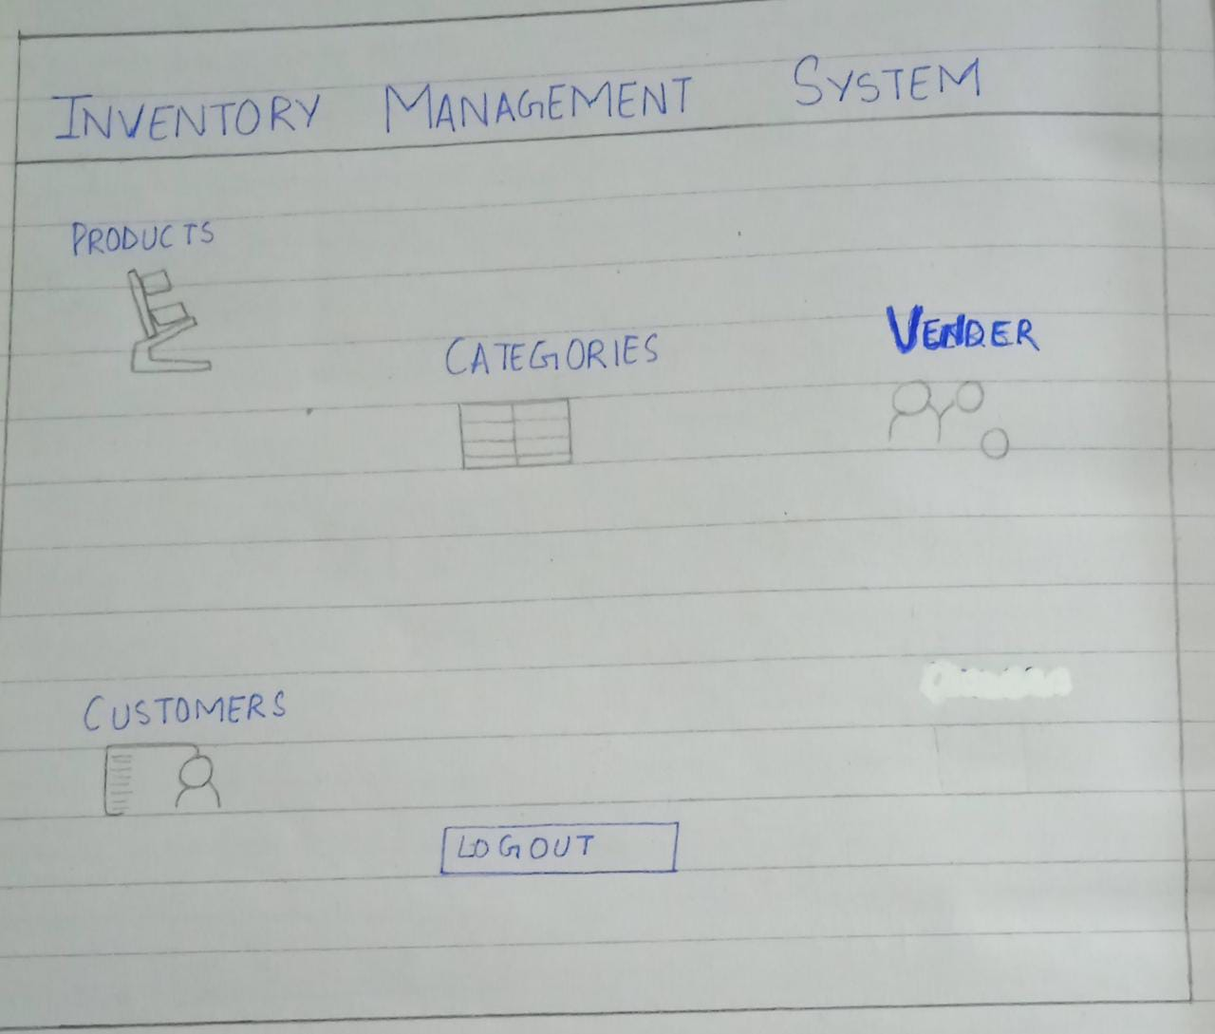

- Diagrammatic Representation of the Overall System
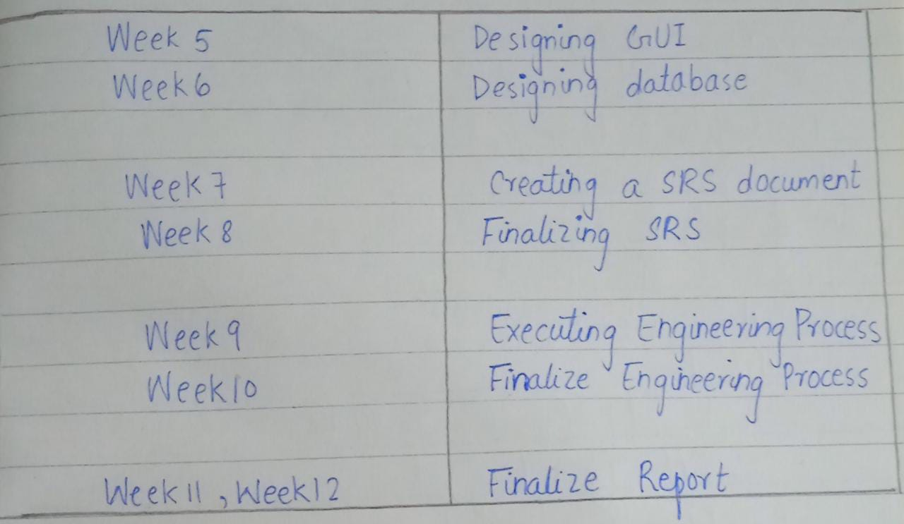

Student’s Signature: ______________ Date: _1_/ March/2022_

